Ideation Phase

Define the Problem Statements

Date | 07 JULY 2026
Roll Number | 23A51A1242
Project Name | Employee ID Card Request
Maximum Marks

Customer Problem Statement Template:

Create a problem statement to understand your customer's point of view. The Customer Problem Statement template helps you focus on what matters to create experiences people will love.
A well-articulated customer problem statement allows you and your team to find the ideal solution for the challenges your customers face. Throughout the process, you’ll also be able to empathize with your customers, which helps you better understand how they perceive your product or service.

Customer Problem Statement
The Employee ID Card Request Management System in ServiceNow is designed to simplify and automate the process of requesting new, replacement, or updated employee ID cards. The application provides a centralized self-service portal where employees can submit requests, upload required documents, and track the status of their requests.
Automated workflows handle approvals, notifications, and request assignments, reducing manual effort and improving efficiency. This solution minimizes delays, increases transparency, and enhances the overall experience for both employees and the HR department.

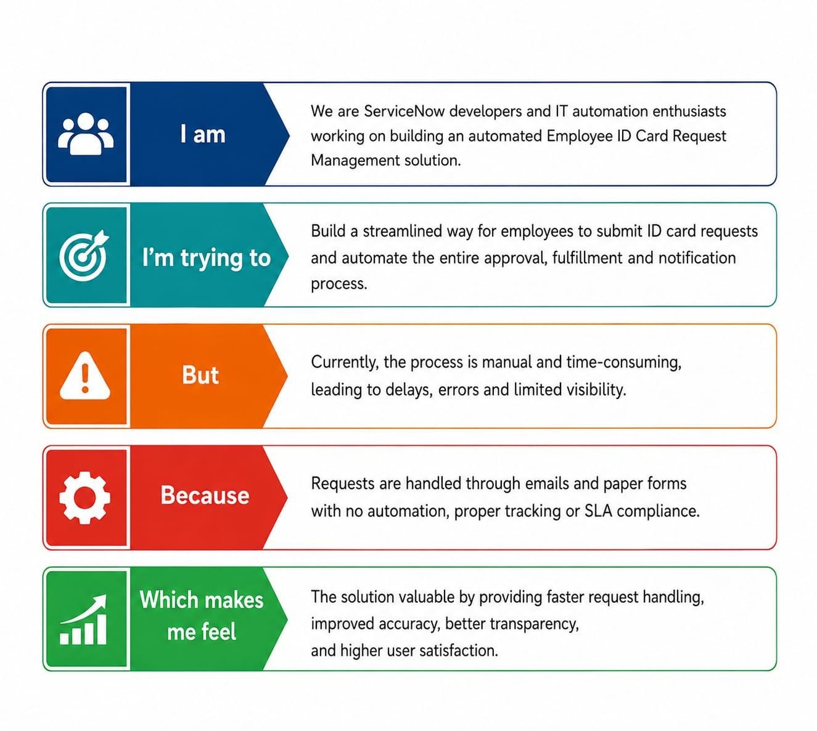

Problem Statement | I  am(customer) | I’m trying  to | But | Because | Which makes me feel
PS-1 | An employee | Request a new ID card | THe request process is slow | It is handled manually | Frustrated
PS-2 | An employee | Replace my lost ID card | I cannot track the request status | There is no tracking system | Anxious
PS-3 | An HR  Administrator | Process employee ID card is ready | Managing requests is difficult | Requests come from emails,calls, and paper forms | Overwhelme d

